**CD Lab**

**Session 1 – Lab 2 (09/12/2020)**

Parthivi Choubey CSE – B - 5th semester

180905456 Roll. no. - 60

**Question 1**

**Code**

#include <stdlib.h>

#include <stdio.h>

int main()

{

FILE *fa, *fb;

char input[256];

printf("Enter file name: ");

scanf("%s",input);

fa = fopen(input, "r");

fb = fopen("output.txt", "w");

if(fa==NULL || fb==NULL) printf("Invalid files\n");

else

{

int c;

while((c = getc(fa))!=EOF)

{

if(c==' ' || c=='\t')

{

while(c==' ' || c=='\t') c= getc(fa);

putc(' ',fb);

}

putc(c,fb);

}

fclose(fa);

fclose(fb);

}

return 0;

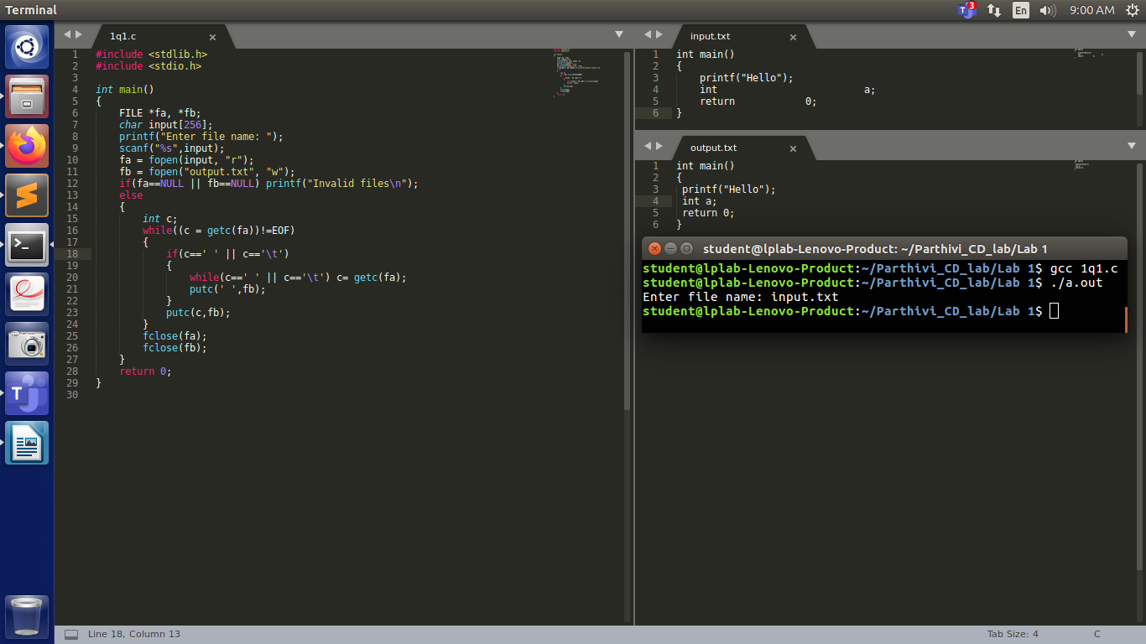}

**Output**

**Question 2**

**Code**

#include <stdlib.h>

#include <stdio.h>

#include <string.h>

const char *directives[] = {"#include","#define","#if"};

int is_directive(char *str)

{

for(int i = 0; i < sizeof(directives)/sizeof(char *); i++)

{

int len = strlen(directives[i]);

if(strncmp(str, directives[i], len) == 0)

return 1;

}

return 0;

}

int main()

{

FILE *fa,*fb;

char input[256];

printf("Enter file name: ");

scanf("%s",input);

fa = fopen(input, "r");

fb = fopen("output.c", "w");

if(fa == NULL || fb == NULL)

{

perror("Invalid files\n");

return 1;

}

char line[256];

while(fgets(line, 256, fa))

{

if(!is_directive(line))

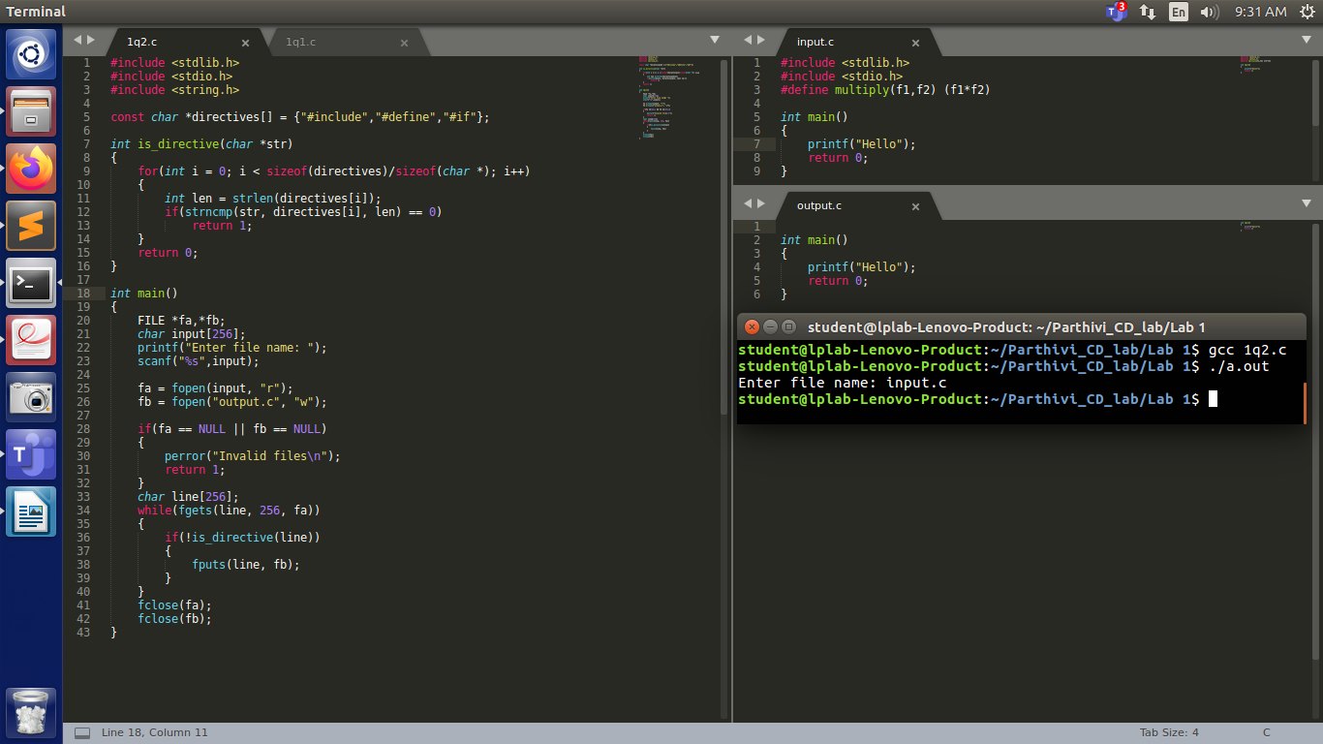 {

fputs(line, fb);

}

}

fclose(fa);

fclose(fb);

}

**Output**

**Question 3**

**Code**

#include <stdio.h>

#include <stdlib.h>

#include <string.h>

#include <stddef.h>

const char *keywords[33] = {"auto", "double", "int", "struct", "break", "else", "long", "switch", "case", "enum", "register", "typedef", "char", "extern", "return", "union", "continue", "for", "signed", "void", "do", "if", "static", "while", "default", "goto", "sizeof", "volatile", "const", "float", "short", "unsigned", "printf"};

int isKeyword (char *word)

{

for (int i=0; i<33; i++)

{

if (strcmp(word, keywords[i]) == 0)

return 1;

}

return 0;

}

int main (int argc, const char * argv [])

{

printf("Enter file name: ");

char input[256];

scanf("%s",input);

FILE *f = fopen(input, "r");

if (f == NULL)

{

printf("Cannot open file\n");

exit(0);

}

char buffer[1024];

const char delimiters[] = " .,;:!?-_(){}[]\n\t";

while (fgets(buffer, 1024, f))

{

char *cp = (char *)malloc(1024 * sizeof(char));

strcpy(cp, buffer);

char *token = (char *)malloc(256 * sizeof(char));

while((token = strsep(&cp, delimiters)))

{

if(isKeyword(token))

{

for (int i=0; i<strlen(token); i++)

printf("%c", toupper(token[i]));

printf("\n");

}

}

}

fclose(f);

return 0;

}

**Output**

